Phloatin Activities Presents:

Explore Romania & Bulgaria – 12 days
May 17 – 28, 2019

Post trip extension to Moldova – May 28 – June 2, 2019
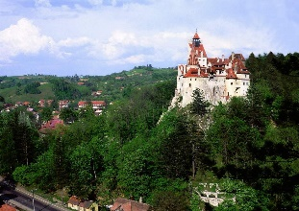
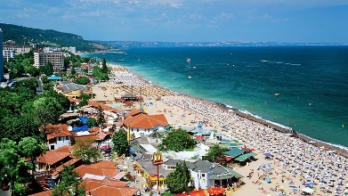
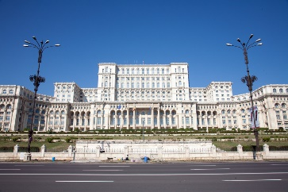
Bulgaria and Romania, part of Eastern Europe, share many similarities but in the same time have their unique traits. During this tour we will discover two capitals, Bucharest and Sofia, two different languages, historical regions, medieval cities and other famous tourist landmarks.

Tour Highlights
- Sofia capital of Bulgaria
- Veliko Tarnovo
- Varna
- Bucharest capital of Romania
- Dracula castle tour
- Plovdiv
- Valley of the Roses
- Peles castle
- Hike in the Carpathian Mountains

$3200*
PER PERSON
Based on double occupancy

Includes:
Round trip air
Accommodations at three and four-star hotels
Transfers
Meals: 9 breakfasts, 1 lunch, 4 dinners
English speaking guides
Sightseeing
Porterage at hotels

Single supplement $325
Land Only (double occupancy) subtract $965

* Final price and itinerary will be set June 1st.

Signups will be taken beginning June 1, 2018

Details and price for Moldova will follow.

Contact:
Karen Wiemeri
klwiemeri@msn.com
612-781-7796

Important dates and payment information:
Deposit:
check for $600 payable to Trip Headquarters on or after June 1, 2018

Payment schedule: $1300 due October 28, 2018, Final payment due February 28, 2019

